5 January 2026
NAME: KHADIJAH MUHD. | Age: AD | Sex: F
Clinical Details: OBS
OBSTETRICS ULTRASOUND REPORT
Maternal Survey:
Internal Os is closed.
Adnexa appear unremarkable.
Foetal Survey: -
- Sonogram revealed SINGLE intrauterine foetus.
- Presentation : CEPHALIC, Lying LONGITUDINAL
- Placenta Location : POSTERIOR
- Amniotic fluid : ADEQUATE
- Cardiac activity : PRESENT AND REGULAR

Biometry:
- Gestation age based on BPD, HC and FL is approximately (GA): 35weeks 04 day(s)
- Expected date of delivery by USG DD) : 08/02/2026 (±2 weeks)
- Foetal weight : 2.26 kg
- Gender : NOT SEEN
IMPRESSION: Single live intrauterine foetus at about 35weeks 04 day(s).
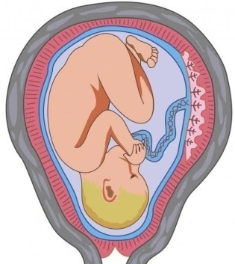
SONOGAPHER

